### **“*HUBCAP will create new opportunities for SMEs in the vast domains of Cyber-Physical Systems (CPSs)*”**

### **Are you an SME wanting to adopt and experiment with Model-Based Design (MBD) tools? Form a consortium with a provider SME and apply to HUBCAP Programme with innovative proposals to experiment & integrate the MBD tools in existing or new CPS solutions!**

### **HUBCAP Call #2.1 - EXPERIMENT is now open for applications!**

[HUBCAP (Digital Innovation Hubs and Collaborative Platform for Cyber-Physical Systems)](http://www.hubcap.eu) is the one-stop-shop for European SMEs wanting to embrace digital innovation using MBD technology for CPSs.

Backed by the [Smart Anything Everywhere](https://smartanythingeverywhere.eu/) initiative, this EU funded project builds on seven Digital Innovation Hubs (DIHs) across Europe, each embedded in its regional innovation ecosystem, offering complementary technical expertise, experimental capabilities and specialist knowledge in CPS application domains.

**HUBCAP will organise three series of Open Calls throughout 2020-2022, with €3,2 million committed in cascade funding for SMEs, namely: Call #1 PULL, Call #2 EXPERIMENT and Call #3 INNOVATE.**

HUBCAP has just launched the first open call of a new series, Call #2.1 EXPERIMENT: we are currently looking for consortia of two SMEs, where MBD CPS users/adopters will work with MBD CPS providers and experiment with MBD tools to implement these digital solutions in their products/services. The goal is to stimulate non-digital SMEs towards the adoption of MBD CPS products & services by applying the HUBCAP ecosystems offers.

**How does it work?**

The new HUBCAP web platform hosts the tools you need to scale ideas and grow your business, supported by experts from our Digital Innovation Hubs (DIHs). SMEs are invited to source potential partners and create consortia composed of one user SME and one provider SME, to experiment with MBD either by integrating already existing MBD tools from the HUBCAP ecosystem offers or implementing these digital solutions in a new MBD CPS solution! Experiments should address a clear business need for the user/adopter SME in terms of improving the lifecycle process or design of CPS for example through visual prototyping or simulation of models.

**What your consortium will receive?**

1. Funding between €30k and €75k (per consortia)
2. Opportunities to connect with users and suppliers from various industries
3. Opportunities to access MBD CPS solutions and services provided by specialized entities
4. The change to reach potential new customers
5. Access to a sustainable ecosystem of stakeholders active in multiple CPS domains
6. Access to support services and workshops with our DIHs.

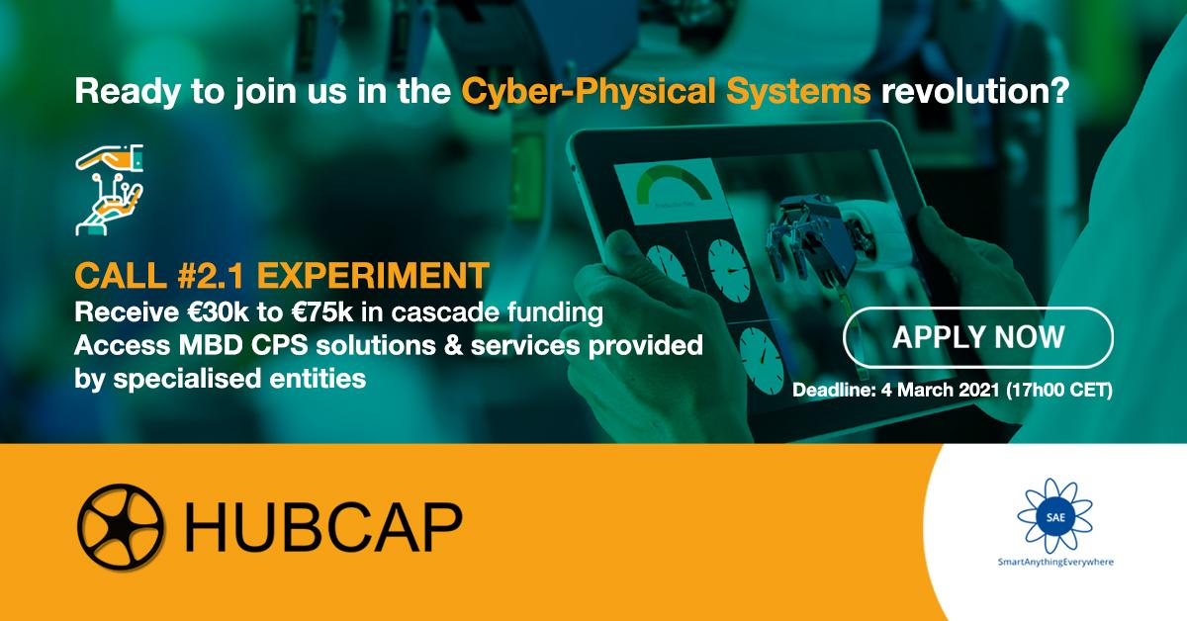

**Interested in joining the Cyber-Physical Systems revolution?**

Applications to Call #2.1 EXPERIMENT are open until 4th March 2021, at 17h00 CET (Brussels Time).

Find out more about HUBCAP on [www.hubcap.eu](http://www.hubcap.eu)

Read the programme guidelines carefully and [APPLY NOW](https://www.f6s.com/hubcapcall2.1experiment/apply)!